MARIABD USER AND DUMP

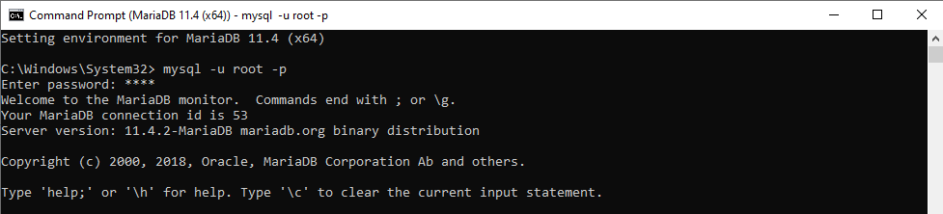

MariaDB [(none)]> show databases;
+--------------------+
| Database |
+--------------------+
| fil_rouge_db |
| gestion_de_stock |
| information_schema |
| mysql |
| performance_schema |
| sys |
| temporary |
+--------------------+
7 rows in set (0.001 sec)
MariaDB [(none)]> use fil_rouge_db;
Database changed

CREATE USER :

MariaDB [fil_rouge_db]> CREATE USER 'fil_rouge_dbo'@'%' IDENTIFIED BY 'password';
Query OK, 0 rows affected (0.002 sec)

MariaDB [fil_rouge_db]> SELECT user FROM mysql.user;
+---------------+
| User |
+---------------+
| fil_rouge_dbo |
| root |
| root |
| root |
| root |
| mariadb.sys |
| root |
+---------------+
7 rows in set (0.001 sec)

GRANT PRIVILÈGES :

MariaDB [fil_rouge_db]> GRANT ALL PRIVILEGES ON fil_rouge_db.* TO 'fil_rouge_dbo'@'%';
Query OK, 0 rows affected (0.002 sec)
MariaDB [fil_rouge_db]> FLUSH PRIVILEGES;
Query OK, 0 rows affected (0.001 sec)

LOG IN NEW USER
MariaDB [(none)]> system mysql -u fil_rouge_dbo -p;
Enter password: ********
Welcome to the MariaDB monitor. Commands end with ; or \g.
Your MariaDB connection id is 8
Server version: 11.4.2-MariaDB mariadb.org binary distribution

Copyright (c) 2000, 2018, Oracle, MariaDB Corporation Ab and others.

Type 'help;' or '\h' for help. Type '\c' to clear the current input statement.

MariaDB [(none)]> show databases;
+--------------------+
| Database |
+--------------------+
| fil_rouge_db |
| information_schema |
+--------------------+
2 rows in set (0.002 sec)

BACKUP :
